Module 10: How to Facilitate Workshop 9
How to File Taxes & Resources for Doing So

Part 1: Introduction to Workshop 9
Welcome back to MHAAO’s Money Basics Facilitator Training!

In this Module, you will learn how to facilitate Workshop 9. The focus of this workshop is taxes – what they are, how to file income tax returns, and tips and resources for filing and paying taxes.

The advanced preparations for Workshop 9 are located in the Facilitator Guide, which will also provide time estimates for each topic and page numbers that correspond to the Student Guide for the topics.

Note that taxes can be a dry, boring, confusing, and frustrating topic for many. It will be key to go through each of the topics as slowly and clearly as possible. It will likely be helpful to use videos and handouts to try and keep the participants engaged.

As always, you will begin each class by welcoming back the participants, facilitating a quick check-in about how their homework assignments went, reviewing the Community Agreements, and providing students with a quick overview of the agenda for that workshop.
Part 2: How to Facilitate a Discussion on Taxes & Mental Health
You will begin this workshop by discussing some of the ways the stress and confusion of tax season may impact a person’s mental health. For many, the stress and pressure to do their taxes may bring about feelings of shame, confusion, anxiety, or guilt.

You will emphasize to the participants that this workshop is designed to relieve some of the stress and negative emotions associated with taxes by providing information, tools, and resources. Like all of the topics in this course, our hope is that participants will feel empowered by learning new information and resources.
Ask the participants to take a few minutes to respond to the questions in the Student Guide:
What, if any, has your experience been with filing and paying taxes? How have taxes affected your mental health?
Invite sharing. This can be accomplished in small groups or as a class. Facilitators should also share their experiences with filing and paying taxes and the impact of tax season on their mental health.
You should emphasize from the beginning of this conversation that you and your co-facilitator are not tax experts. This is a legal requirement. Make it clear that you will share information and resources with the class but are not able to provide legal advice and may not have the knowledge or expertise to answer all tax-related questions.

Because of this, it may be helpful to find and share a few websites with participants where they can find tax experts or legal advice in their area if they need it.
Part 3: Going Over Tax Basics
In this section, you will discuss why we pay taxes, where the money goes, and the differences between state and federal income taxes.
Ask the class to list examples of public services and government infrastructure paid for by taxes, and write these on the whiteboard or Jam Board. Using this list and the information in the Student Guide, you can explain the importance of tax revenue.
Research if your state requires an income tax return and plan accordingly. You will need to do some advanced preparations before this workshop to gather information on taxes in your state. Information is included in the Student Guide for Oregon’s tax system, which you can use as an example.
Part 4: Going Over Common Forms & Terms
In this section, you will discuss common tax terms and forms that will be helpful in filing federal and state tax returns.
You can share the common tax forms discussed in the Student Guide on the screen. These include forms 1040, W-2, and W-4.
You will provide information for each form and its uses and allow time for questions.
After this, you will go through the common tax terms and definitions in the Student Guide one by one, leaving space for questions or comments. You can ask participants to take turns reading each section aloud. Participants can volunteer to read.
In this section, you will pay special attention to deductions and credits.
Deductions reduce a person’s tax obligation by lowering their gross income. Gross income is the sum of all wages, tips, and other earnings before taxes. When filling out their federal and/or state tax return, taxpayers can choose to take the standard deduction or itemize their deductions. Both will reduce the amount of one’s income that is subject to taxes.
The standard deduction depends on a person’s filing status, age, and income. Itemized deductions include a variety of expenses the taxpayer has incurred over the year, like charitable contributions, daycare costs, medical bills, or tuition.
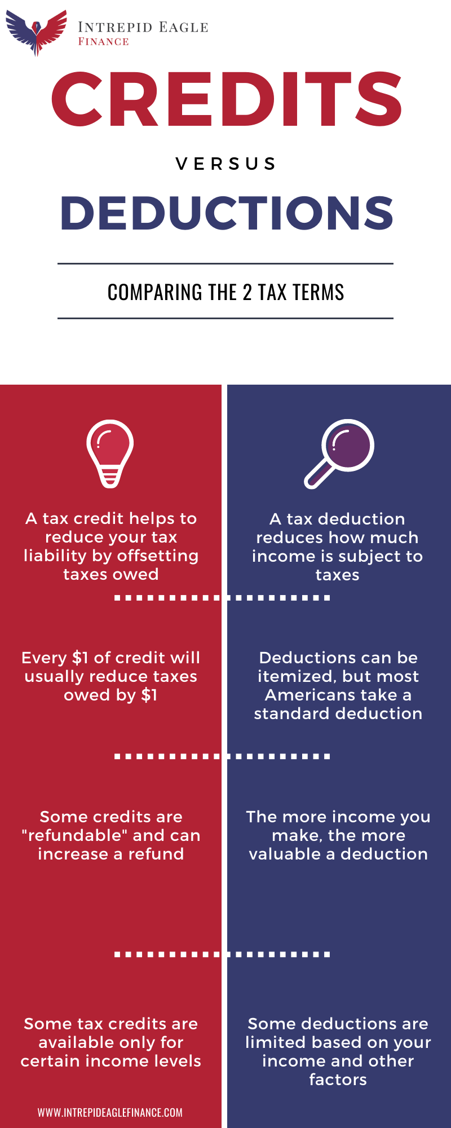
Tax Credits help to reduce the amount of taxes a person will pay. For example, if an individual owes $5,000 in taxes but qualifies for a $1,000 tax credit, then their tax liability will be lowered to $4,000. A tax liability is a payment owed by an individual or business to a federal, state or local tax authority. Income taxes, sales tax, and capital gains tax are all forms of tax liabilities. For our purposes, we will focus on income taxes. When a person earns a high-enough income, they are subject to income taxes, which most Americans pay to the IRS every April in the form of tax liabilities. An individual can lower their tax liability by claiming deductions and credits.
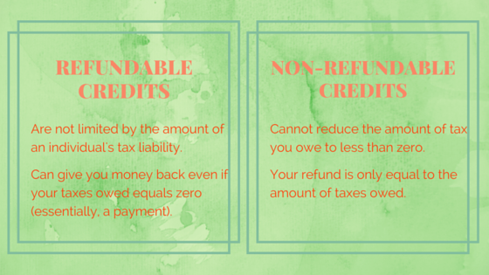
Some credits are refundable, which means the taxpayer will get money back even when the credit is more than the tax they owe. Other credits are nonrefundable and only refund a person’s money up to the amount of taxes they owe.

Earned Income Tax Credit (EITC) is a refundable credit that can lower a person’s tax bill. If an individual or family has a lower income, they may qualify for this credit, which can often result in a tax refund. There is a helpful handout from the IRS on who qualifies for EITC, located in the Facilitator Toolkit for this workshop.
*find a graphic to explain this - can’t find anything
Part 5: How to File an Income Tax Return
In this section, you will go through the following steps on how to file federal and state income tax returns.
Step 1: Decide whether you will be hiring a tax professional, using tax software, or filing by mail.
Step 2: If you’ve decided to file yourself, you will begin by gathering documentation of your different sources of income, such as W-2 forms and/or 1099 forms, and accessing IRS Form 1040.
Step 3: Complete Form 1040 online or by hand by following the IRS’s, or by answering the questions asked by the guided tax preparation website.
You will:
- Choose your filing status. There are 5 different filing statuses for the federal tax return: 1) single, 2) married filing jointly, 3) head of household, 4) married filing separately, and 5) qualified widow/widower with a dependent child. Your filing status depends on a number of criteria and determines the forms you need to fill out and the filing requirements, credits, deductions, exemptions, and tax rates you are subject to.
- Determine if you are claiming any dependents. A dependent can be a qualifying child or qualifying relative (sibling, parent) for whom you provide over half of their annual support.
- Explore what tax deductions and credits you may qualify for. Tax deductions and credits can lower your tax bill or increase your refund.

Step 4: Submit. Submit your federal (and state, if applicable) income tax return(s) online using the IRS website or tax preparation software or by mail by the deadline (mid-April).
Using the information in the Student Guide, discuss each step and what it entails, and ask participants if they have any questions. Pay special attention to deductions and credits, going through the information in the Student Guide on claiming deductions and credits, when to itemize and when to take the standard deduction, common examples, etc.
There are some helpful handouts and videos located in the Facilitator Toolkit for understanding this process.
An essential part of this workshop is to emphasize that there are a number of free resources for filing taxes available to lower-income individuals. These include:
- Guided tax preparation websites, which partner with the IRS to provide tax assistance for free. These can be found on the IRS Free File website.
- Volunteer Income Tax Assistance (VITA), which is tax assistance by trained volunteers for lower-income people, people with disabilities, or people who have limited English proficiency
- Tax Counseling for the Elderly (TCE), which is similar to VITA but is free tax assistance for senior citizens.
Emphasize that if participants have access to a computer and secure internet access, filing online using the free tax assistance websites recommended by the IRS is most likely the easiest, cheapest, and most efficient way to file federal and state income tax returns.
These websites do the math for a person and fill out their federal and oftentimes state tax return forms simply by asking them questions. All a person needs is their W-2 and/or 1099 form, their current filing status, any adjustments to their income, and if they are claiming any dependents, deductions, and/or credits.
However, facilitators should note that these websites can sometimes be difficult to navigate, and finding someone to assist with their taxes, such as a VITA volunteer, might be one of the best strategies to file their tax returns quickly and easily.
Part 6: How to Pay Taxes & Things to Keep in Mind
Using the information in the Student Guide, discuss as a group some situations that may lead a person to owe a lot in income taxes. These can include:
- Withholding too little: The amount withheld from your paycheck each pay period is an estimate of what you’ll owe in taxes when it is time to file. If you overpay or “over-withhold,” you will receive a tax refund. If you do not pay enough or “under-withhold,” you will have to pay the IRS additional tax money.
- Filing late: If you file late and don’t get a tax extension in time, you may owe late fees and interest that will make your tax bill higher. The IRS Tax Filing Deadline, also known as Tax Day, is April 15, unless it falls on a holiday or weekend, in which case it will be the next business day.
- Changes in tax code: New tax laws can put you in a different tax bracket, which can affect whether you get a refund or whether you owe the IRS.
- Higher-income: If your income increases, so do your taxes. If you get moved up a tax bracket due to an increase in wages, you may have to pay more in taxes than in previous years.
- Changes in deductions: You may owe taxes because you no longer qualify for certain credits or deductions, such as earned income credit or the child tax credit.
Using the information in the Student Guide, go through the different options for paying taxes, writing them on the whiteboard as they come up. Some options for payment include:
- Paying the IRS in full with a debit or credit card, by mailing a check, or transferring money directly from your bank account
- Arrange a payment plan with the IRS
- Request a temporary delay of the payment date from the IRS
- Submit an Offer in Compromise form to the IRS, which allows you to settle your tax debt for less than the full amount you owe
- Or take out a private loan. This is a last-resort option and is not recommended
As a class, brainstorm the pros and cons of each payment option.
Important Information to Keep in Mind
Remind participants that the deadline to file income tax returns is around April 15. Check the IRS website for more information.
Using the information in the Student Guide, discuss the possibility of requesting an extension from the IRS, how it works, and why you may need one. Brainstorm the pros and cons of tax extensions, leaving space for questions.
Next, you will go over the definition of back taxes and how serious they can be. Discuss ways to avoid the interest, penalties, and possibility of asset seizure from back taxes. Ask the participants if they have any questions.

Part 7: Wrap Up
Congratulations, you’ve completed Module 10 of the Money Basics Facilitator Training! Before you continue with your day, please complete the review questions and check out the homework assignments.

